http://mandypc:8399/201504layer/
http://mandypc:8099/arcgismanager/main/main.jsf （ arcgismanager / gisserver ）

统计功能，Sum， 修改css， 二次开发
统计字段功能 （ArcGIS Server开发从入门到精通.pdf）

How to write a custom task

http://resources.esri.com/help/9.3/arcgisserver/adf/java/help/doc/5257ae83-0b1e-4dbb-a120-8a4c79d14d50.htm

Additional Requirements
- Access to a geographic information system (GIS) service supported by the Web Application Developer Framework (ADF). You can use the world.mxd file at [Web ADF install directory] \ArcGIS\java\samples\data\mxds to create either an ArcGIS Server service or an ArcIMS Service.
- Eclipse IDE with the ArcGIS Server plug-in. In Eclipse, click File, click New, and click Project. Select ArcGIS Web Project under ESRI Templates and create a new Web application called georss.

C:\Program Files (x86)\ArcGIS\java\samples\data\mxds
C:\Program Files (x86)\ ArcGIS/java/tools/eclipse_plugin/arcgis_update_site

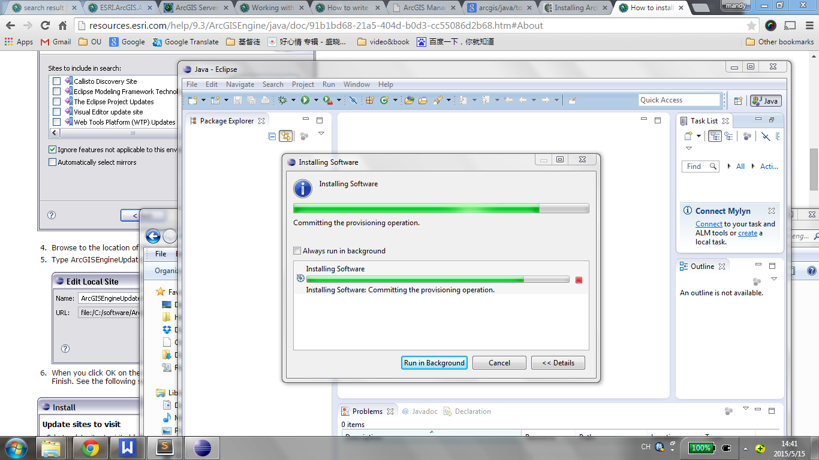

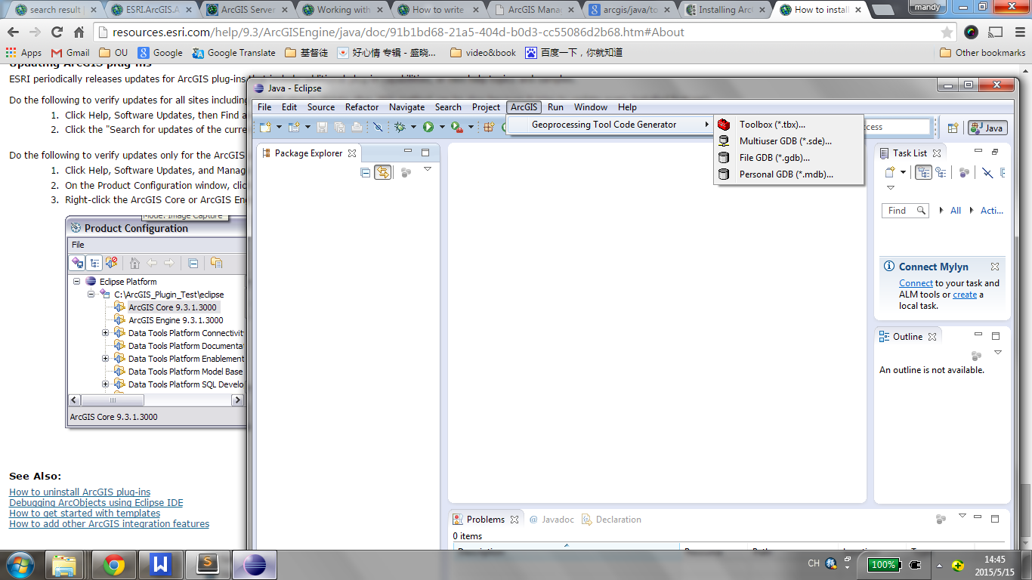

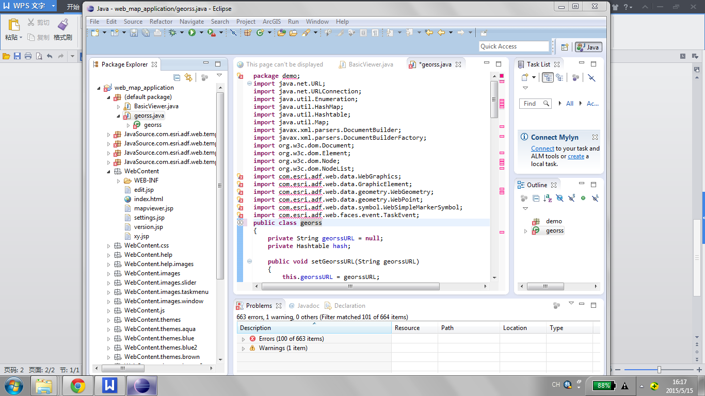

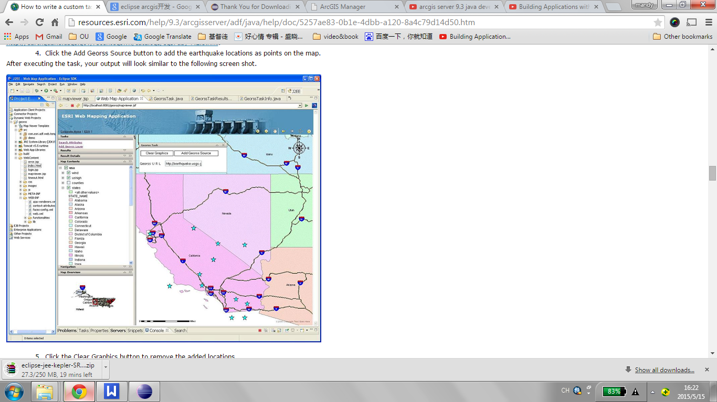

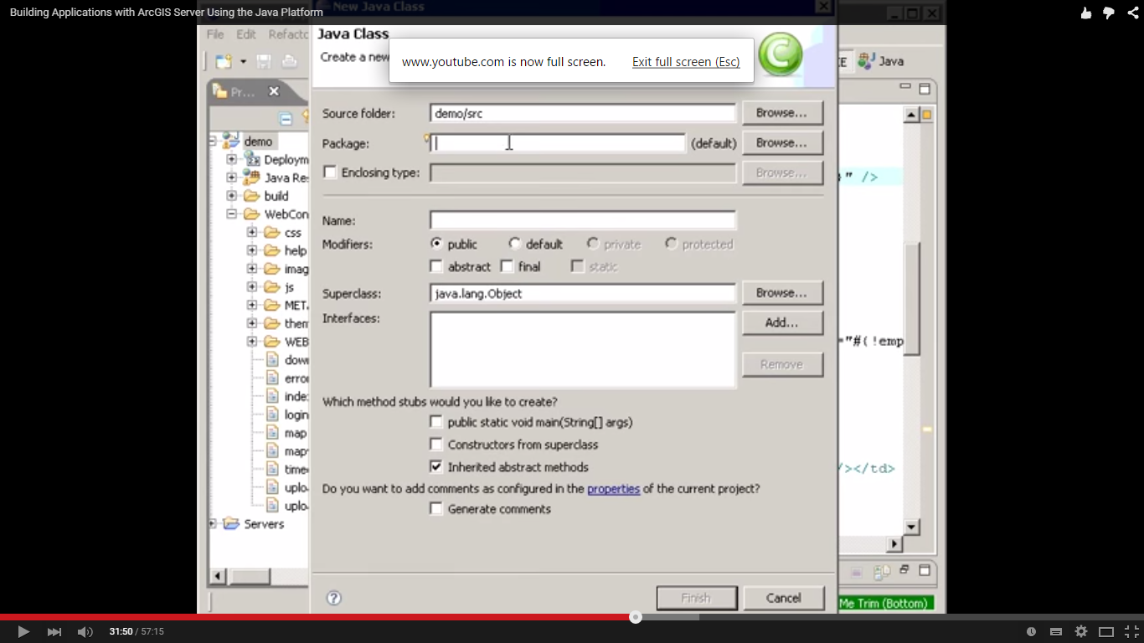

下载 J2EE 软件。

看视频和资料
https://www.youtube.com/watch?v=Wcj0QtC-xks
http://resources.esri.com/help/9.3/arcgisserver/adf/java/help/doc/5257ae83-0b1e-4dbb-a120-8a4c79d14d50.htm

